1. Give matrix representation for 2D scaling.

S=S*P

S=|sx 0| x |x|

|0 sy| |y

|

1. Translate the polygon with co-ordinates A (3, 6), B (8, 11), & C (11, 3) by 2units in X direction and 3 units in Y direction.

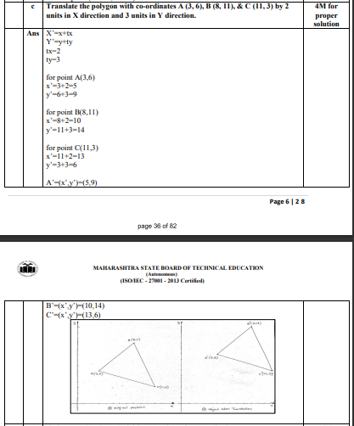

1. Define Window, Viewport, Clipping, World co-ordinate system.

Window – The process of selecting the part of real world scene to display on device is called windowing.

Viewport – An area on display device to which window is mapped is called viewport.

Clipping – Is the process of deciding and removing the portion of object which is outside the clipping window.

WCS - World Coordinate Systems (WCSs) describe the geometric transformations between one set of coordinates and another. A common application is to map the pixels in an image onto the celestial sphere. Another common application is to map pixels to wavelength in a spectrum.

1. List out different line clipping algorithm.
2. Cohen Sutherland Line clipping algorithm.
3. Cyrus Beck Line clipping algorithm.
4. Liang Barsky Line Clipping Algorithm
5. Midpoint Subdivision Line Clipping Algorithm
6. What is mean by interpolation?

Specify a spline curve by giving a set of coordinate positions, called control

points, which indicates the general shape of the curve These, control points

are then fitted with piecewise continuous parametric polynomial functions in

one of two ways. When polynomial sections are fitted so that the curve passes

through each control point, the resulting curve is said to interpolate the set of

control points. On the other hand, when the polynomials are fitted to the

general control-point path without necessarily passing through any control

point, the resulting curve is said to approximate the set of control points

interpolation curves are commonly used to digitize drawings or to specify

animation paths. Approximation curves are primarily used as design tools to

structure object surfaces an approximation spline surface credited for a

design application. Straight lines connect the control-point positions above the

surface

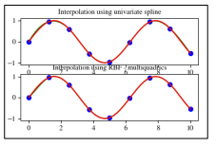

1. Translate a triangle with vertices A(2,2,2),B(3,4,7)and C(8,9,12) by translation vector [ 2 4 5].

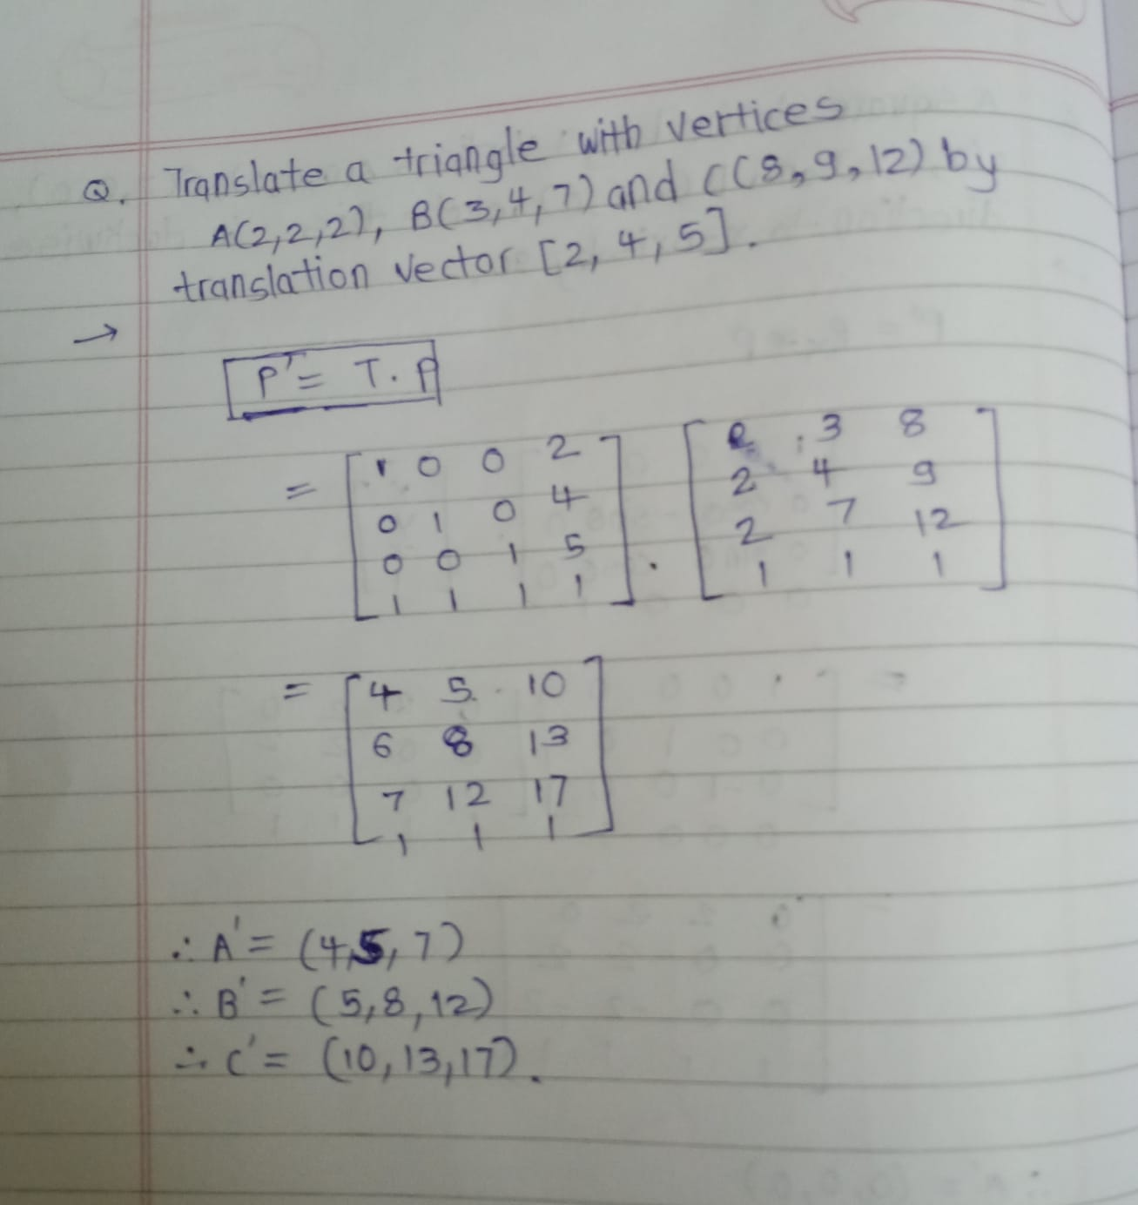

1. Write the midpoint subdivision algorithm for line clipping.

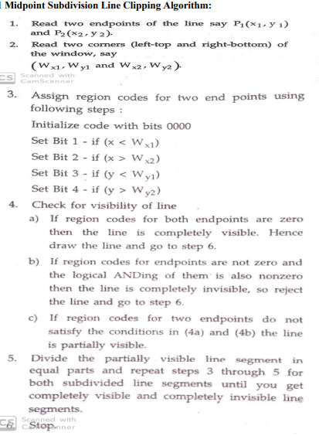

1. Explain differ types of Text clipping in brief.

Many techniques are used to provide text clipping in a computer graphics. It depends on the

methods used to generate characters and the requirements of a particular application. There

are three methods for text clipping which are listed below −

1) All or none string clipping

2) All or none character clipping

3) Text clipping

The following figure shows all or none string clipping −

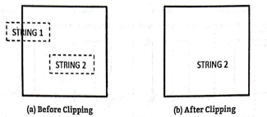

In all or none string clipping method, either we keep the entire string or we

reject entire string based on the clipping window. As shown in the above

figure, Hello2 is entirely inside the clipping window so we keep it and Hello1

being only partially inside the window, we reject.

The following figure shows all or none character clipping –

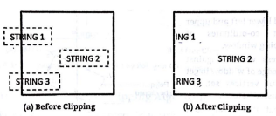

This clipping method is based on characters rather than entire string. In this

method if the string is entirely inside the clipping window, then we keep it. If it

is partially outside the window, then −

You reject only the portion of the string being outside

If the character is on the boundary of the clipping window, then we discard that

entire character and keep the rest string.

The following figure shows text clipping –

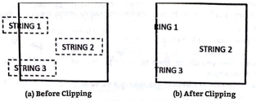

This clipping method is based on characters rather than the entire string. In this

method if the string is entirely inside the clipping window, then we keep it. If it

is partially outside the window, then you reject only the portion of string being

1. Explain Koch curve with diagram.

Koch Curve: - In Koch curve, begin at a line segment. Divide it into third and replace the

center by the two adjacent sides of an equilateral triangle as shown below.

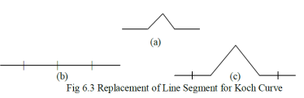

This will give the curve which starts and ends at same place as the original segment but is

built of 4 equal length segments, with each 1/3rd of the original length. So the new curve

has 4/3 the length of original segments. Repeat same process for each of the 4 segment

which will give curve more wiggles and its length become 16/9 times the original.

Suppose repeating the replacements indefinitely, since each repetition increases the length

by a factor of 4/3, the length of the curve will be infinite but it is folded in lots of tiny wiggles.

1. Describe B-spline curve.

Concept of B-spline curve came to resolve the disadvantages having by Bezier curve, as we all know that both curves are parametric in nature. In Bezier curve we face a problem, when we change any of the control point respective location the whole curve shape gets change. But here in B-spline curve, the only a specific segment of the curve-shape gets changes or affected by the changing of the corresponding location of the control points.

In the B-spline curve, the control points impart local control over the curve-shape rather than the global control like Bezier-curve.

B-spline curve shape before changing the position of control point P1 –

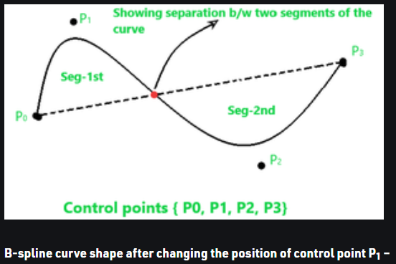

1. Write an algorithm for DDA arc generation.

Step 1: Read the center of curvature, say (x0, y0)

Step 2: Read the arc angle thita, say thita

Step 3: Read the starting point of the arc, say (x, y)

Step 4:

Calculate d thita

D thita = Min(0.01, 1/(3.2X(|x-x0|+|y-y0|)))

Step 5: Initialize angle = 0

Step 6: while(angle < thita){

Plot(x,y)

X=x-(y-y0)*d thita

Y=y-(x-x0)*d thita

Angle = angle + d thita

}

1. Explain Hilbertz Curve.

The Hilbert curve is a space filling curve that visits every point in a square grid with a size of 2×2, 4×4, 8×8, 16×16, or any other power of 2. It was first described by David Hilbert in 1892. Applications of the Hilbert curve are in image processing: especially image compression and dithering. It has advantages in those operations where the coherence between neighbouring pixels is important (see Douglas Voorhies's contribution to the "Graphic Gems" series). The Hilbert curve is also a special version of a quadtree; any image processing function that benefits from the use of quadtrees may also use a Hilbert curve.

1. Write an algorithm for Cohen-sutherland line clipping algorithm.

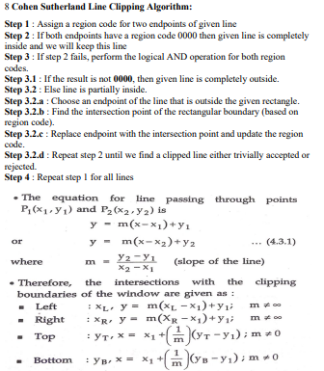

1. Explain Bezier Curve.

A Bézier curve is a parametric curve that uses the Bernstein polynomials as a basis. A Bézier curve of degree (order ) is represented by. (1.40) The coefficients, , are the control points or Bézier points and together with the basis function. determine the shape of the curve.

1. A square is defined by 4 vertices A(0,0,0),B(2,0,0),C(2,2,0)and D(0,2,0) rotate this in clockwise direction to x-axis by 90.